

STATE OF INDIANA

Request for Information 20-030

Addendum #2

INDIANA DEPARTMENT OF ADMINISTRATION

On Behalf Of
Indiana Department of Child Services

Request for Information Regarding:
Community-Based Family Preservation Services

Response Due Date: Monday, August 26, 2019

David Brandon-Friedman, Sr. Account Manager
Indiana Department of Administration
Procurement Division
402 W. Washington St., Room W468
Indianapolis, Indiana 46204

Summary of Changes
Two RFI 20-030 documents have been updated. Additions in the RFI document have been made in red.

The following additions have been made to the RFI 20-030 Document:

- In Section II, Background, the following information has been added:

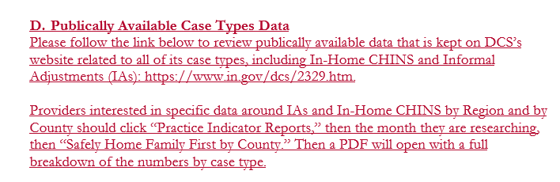

The following revisions have been made to the Cost Template, Attachment A:

- In tab II. Personnel:
  - Column F - Fringe Benefit & Payroll Tax Cost (Current) has been reformatted to unlock the cells.
  - Column G – FTE (Projected) has been reformatted to allow numerical entry with decimals.

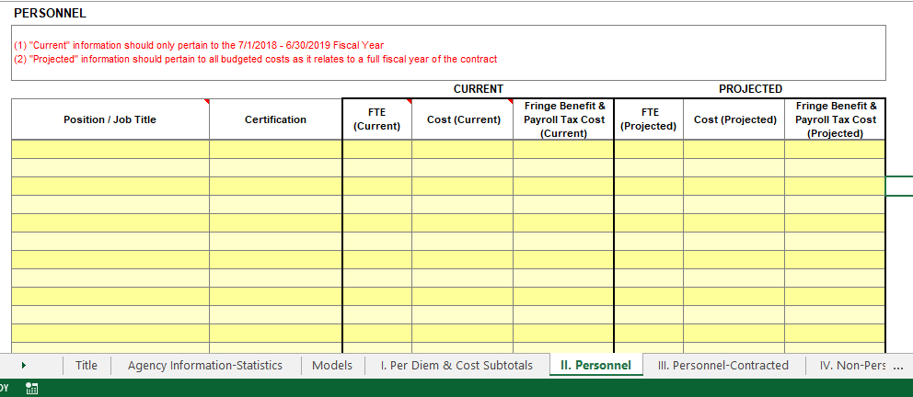

A recording of the Pre-Response Conference held on August 2, 2019 can be found at: https://indiana.adobeconnect.com/ps6ntn4ja1qp/.

